**Strategic Business Plan for HappyFresh Malaysia**



Contents

[Section 1: Executive Summary 3](#_Toc502951142)

[1.1 Our Mission 3](#_Toc502951143)

[1.2 The Company and Management 3](#_Toc502951144)

[1.3 Our Services 3](#_Toc502951145)

[1.4 Our Competitive Advantages 3](#_Toc502951146)

[1.5 Financial Projections 5](#_Toc502951147)

[1.6 Start-up Financing Requirement 5](#_Toc502951148)

[Section 2: Elevator Pitch 6](#_Toc502951149)

[Section 3: Company Mission Statement 9](#_Toc502951150)

[Section 4: SWOT 10](#_Toc502951151)

[Section 5: Goals 11](#_Toc502951152)

[Section 6: Key Performance Indicators (KPIs) 12](#_Toc502951153)

[Section 7: Target Customers 13](#_Toc502951154)

[Section 8: Industry Analysis 14](#_Toc502951155)

[Section 9: Competitive Analysis & Advantage 17](#_Toc502951156)

[Section 10: Marketing Plan 20](#_Toc502951157)

[Section 11: Team 21](#_Toc502951158)

[Section 12: Operations Plan 22](#_Toc502951159)

[Section 13: Financial Projections 24](#_Toc502951160)

# Section 1: Executive Summary

## Our Mission

HappyFresh mission is to provide a professional personal shopper experience to our client, and delivering everything you need from the supermarket at your doorsteps within 1 hour with the highest quality products.

## The Company and Management

HappyFresh is headquartered in Jakarta, Indonesia. The company has seven co-founders, each with experience in the tech business. Markus Bihler serves as CEO, Fajar Budiprasetyo as CTO, Benjamin Koellmann as COO, Dr. Konstantin Lange as CFO, Kai Kux as CCO, executive chairman and investor Tim Marbach, and Stefan Jung from [Monk’s Hill Ventures](http://www.monkshill.com/) as advisor. The team’s experience includes careers in [Blackstone](http://www.blackstone.com/), Goldman Sachs, the Boston Consulting Group, J.P. Morgan, Rocket Internet, Lazada Group, as well as founding and exiting [KaufDA](http://www.kaufda.de/) in Germany and [Koprol](https://www.techinasia.com/tag/koprol/) in Indonesia.

## Our Services

We offered personal shopper experience for buying groceries from our customer’s favorites supermarket and delivering them to the customer doorsteps. The method of our service offering is via online marketplace and mobile apps.

## Our Competitive Advantages

Based on the analysis done, we believe our competitive advantage is as below[[1]](#footnote-1)

1. Regional teams focus on expansion while headquarter takes the rest of jobs

We have good management process in place to help drive our expansion and reducing cost.

1. Asset light and highly localised model facilitate the growth of users

HappyFresh is one of well-known for being asset light. And that permits for a loose cost structure — mostly labor cost — and easily scalable model. By thinning the budget on assets, the regional team can invest most of its capital in providing discounts to attract users and organize more marketing campaign to bring in first-time user.

1. One hour delivery brings supermarkets to be just around the corner

With the introduction of one-hour grocery delivery services, however, these two problems may soon be a distant past. For some, a few dollars is a small price to be pay for the time that could be saved. As these distant supermarkets become easily reachable, customers may be incentivized to shop more frequently and spend more.

1. The niche market they targeted is the one with high spending power

Some may doubt the feasibility of the grocery delivery service based on the irreplaceable personal touch in mortar-and-brick — specifically mom-and-pop local produce — stores. Also, since HappyFresh usually charges delivery fee and other expenses to customer (HappyFresh plays a middleman between customer and supermarket), the total shopping expense could be even higher than shopping in physical stores. Indeed, it is undoubtedly true for majority of customers, but it not applicable to people with high spending power. Even though this group of people is only 1 per cent of the total population, the profit they bring to companies is still a substantial figure.

1. Collaboration with competitors to reclaim this new market

There exist numerous grocery players trying to enjoy the first-mover advantages. Technically, they may be contenders but actually they are partners working together to educate customers and markets. This strategy is borne out of the need to change ingrained shopping habit — requiring both intensive capital and great patience. Therefore, embracing incoming competitors to work on these historically epochal projects becomes necessary and could accelerate changes in shopping habit.

## Financial Projections

As a newly startup company, Happyfresh fund mostly coming from external investor. They received USD12 million in a SERIES A funding in September 2015, and follow by more than USD12 million in SERIES B funding in August 2016.

In the early setup 2014-2015, large portion of the expenses are spent on new hiring for IT team, marketing and operation.

In the recent online news 2017, Happyfresh has allocated huge amount of money (more than USD6 million) into awareness and market growth.

The market for online grocery shopping in Indonesia and other Asian countries could see a double-digit growth in market turnover to be worth S$19 billion ($13 billion) by 2020. It is huge market potential for Happyfresh and other online grocery platform players.

## Start-up Financing Requirement

As for now, HappyFresh already had USD 24 million in funding. In order to fuel our expansion to other cities that we have identified as great market for our services (Johor Bahru, Pulau Pinang etc), and also to make our present felt, by advertisement and promotions, we required another USD12 million in funding. We plan to do this in the next SERIES C funding scheduled in 2018.

# Section 2: Elevator Pitch

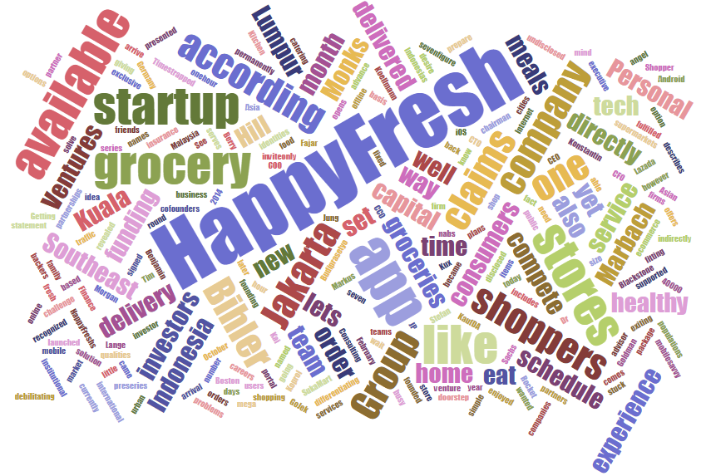

About Happy Fresh

HappyFresh is the first and fastest-growing online grocery platform in Southeast Asia. Founded in 2014, HappyFresh was launched by skilled entrepreneurs, using their extensive experience in building international companies to revolutionize the online grocery market in Asia.

The company has seven co-founders, each with experience in the tech business. Guillem Segarra serves as CEO, Fajar Budiprasetyo as CTO, Benjamin Koellmann as COO, Dr. Konstantin Lange as CFO, Kai Kux as CCO, executive chairman and investor Tim Marbach, and Stefan Jung from [Monk’s Hill Ventures](http://www.monkshill.com/) as advisor.

The team’s experience includes careers in [Blackstone](http://www.blackstone.com/), Goldman Sachs, the Boston Consulting Group, J.P. Morgan, Rocket Internet, Lazada Group, as well as founding and exiting [KaufDA](http://www.kaufda.de/" \t "_blank) in Germany and [Koprol](https://www.techinasia.com/tag/koprol/) in Indonesia. Together with an all-star team based in Jakarta, HappyFresh has quickly expanded to Malaysia, Indonesia and Thailand with ambitious growth plans, you can expect to see HappyFresh launching in more Southeast Asian cities in the near future.[[2]](#footnote-2)

HappyFresh collaborates with supermarkets to bring our customers all their favorite products. We enable customers to easily order from their favorite supermarkets, via our website and mobile app. HappyFresh is dedicated to providing a high-quality service for our customers, training our personal shoppers to pick only the best-quality items before our delivery drivers beat the traffic to ensure your order is delivered on time, every time.

HappyFresh’s main partners:

Indonesia: Ranch Market, Farmers Market, Carrefour, Lotte Mart, Super Indo and Grand Lucky;

Malaysia: Tesco, Jasons Food Hall, Aeon Big, Winetalk, Mercató, Cold Storage, de Market, Sam’s Groceria;

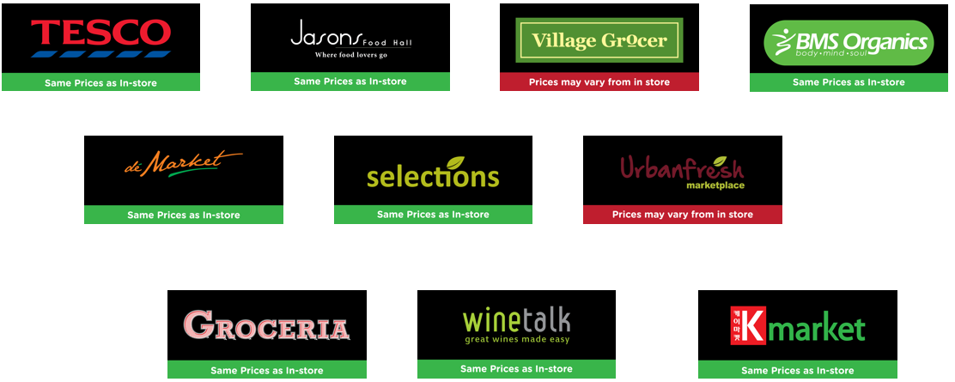

Figure: HappyFresh partner’s in Malaysia

Thailand: Tesco Lotus, Big C, Wine Market, Gourmet Market and Sunshine Market.

Company details

Website: <http://happyfresh.com>

Headquarters: Jakarta

Year founded: 2014

Company type: Privately Held

Company size: 201-500 employees

Specialties: Grocery delivery, Online marketplace, and Mobile apps

A close up of a map

Description generated with high confidence

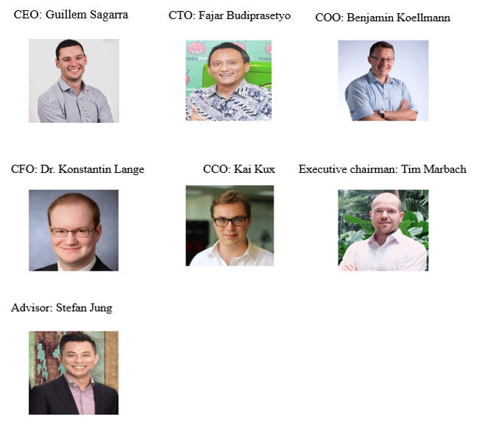

Figure: Management team of HappyFresh

# Section 3: Company Mission Statement

Mission

HappyFresh mission is to provide a professional personal shopper experience to our client, and delivering everything you need from the supermarket at your doorsteps within 1 hour with the highest quality products.

Vision

Our vision is to be the number 1 personal shopper services provider in South East Asia.

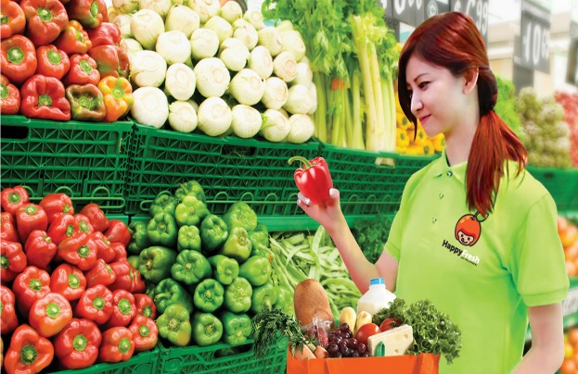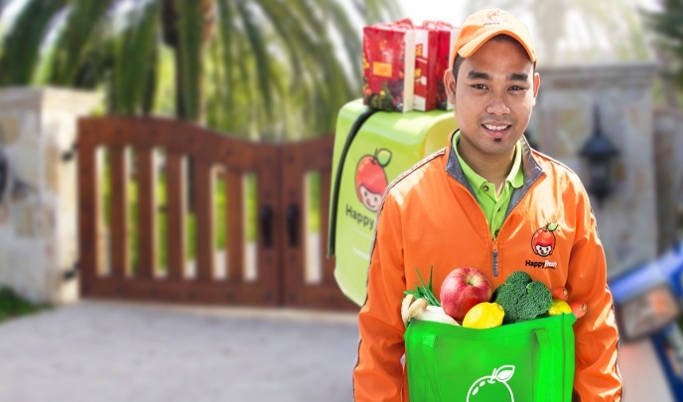

# Section 4: SWOT

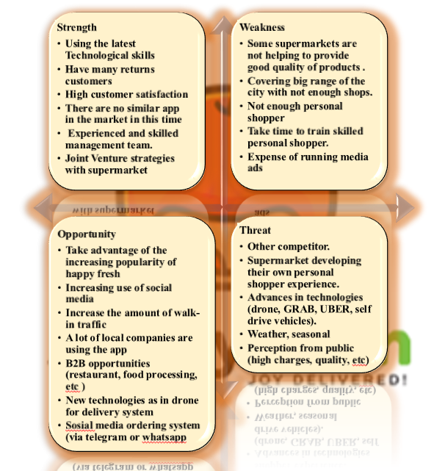

# Section 5: Goals

In order to support our vision and mission, we set our Business Goals as below

1. Reduce overall budget costs by 10% by 2020
2. Increase market share by 5% by 2020
3. Increase revenues by 20% by 2020
4. Increase customer satisfaction by 5 pts by 2020
5. Enhancing our brand and reputation.
6. Improving our customer management

# Section 6: Key Performance Indicators (KPIs)

Happy fresh has multiple factors for our KPI’s and with different indicators.

For internal and external factors to make sure that we are aligned with our plans

External:

* increase email subscription, download, App installations
* sales revenue

we are trying to increase our sales revenue trying to move from start-up company

* increase registered users
* increase number of leads (per day, week, month)
* reduce cost of lead
* lifetime value of customers  
  we want loyal customers use our app very frequent not only for once
* transaction value per customers  
  depending on the customer paying itself so more increase of these value means more loyalty

Internal:

* blog posts
* eBook
* Videos
* social media marketing
* social media development cost

all the internal factors trying to increase number of our employees and enhance the skills for the employees what we have

# Section 7: Target Customers

Because of rushing our daily life grocery these days is really difficult task for all people   
family, singles (males/females) in all range of ages. And our customers are not only individual because we are providing (B->B) services.

By providing grocery for companies and big firms who can save a lot of time for own employee to do this task.

Through analysis, we identified our customer as below,

1. Companies and big firm

Some companies provide fresh fruits to their employees. By using our expertise, we provided them the supply on daily basis with the highest quality of products.

1. Restaurant, small food processing company.

Some restaurants and food processing company with quality ingredient in mind. We provide the expertise in selecting the best materials and delivering them directly to their place.

1. Urban

Most of the urban dwellers will prefer to do online shopping

1. Student
2. Shift workers

# Section 8: Industry Analysis

For industry analysis we’re using BCG Growth-Share Matrix, Product lifecycle, and Consumer adaptation curve.

BCG Growth-Share Matrix

BCG Growth-Share Matrix is used to identify where HappyFresh is now within the industry.

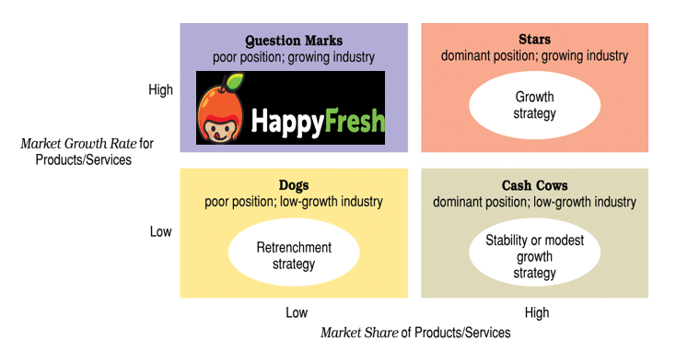

Figure: BCG Growth-Share Matrix of HappyFresh [[3]](#footnote-3)

From this matrix, we put HappyFresh in Question Marks.

Criteria for Question Marks are as below,

Question marks (also known as problem child) are growing rapidly and thus consume large amounts of cash, but because they have low market shares they do not generate much cash. The result is a large net cash consumption. A question mark has the potential to gain market share and become a star, and eventually a cash cow when the market growth slows. If the question mark does not succeed in becoming the market leader, then after perhaps years of cash consumption it will degenerate into a dog when the market growth declines. Question marks must be analyzed carefully in order to determine whether they are worth the investment required to grow market share. [[4]](#footnote-4)

Our strategy for HappyFresh will be **growth strategy** which is seeking an **increase in size** and the **expansion through current operations**.

Product lifecycle

Product Lifecycle analysis is a tool to predict how sales will develop based on the age of the product category. Marketers and strategists can use this analysis to predict sales growth, associated customer and competitor behaviors, and, in turn, devise the appropriate product marketing strategy.

The Product Lifecycle itself it divided into 4 stages of development: Introduction, Growth, Maturity (and Saturation), and Decline (and Termination). [[5]](#footnote-5)

We believe that HappyFresh is in between **introduction** & **growth** stage of retail personal shopper service in South East Asia region.

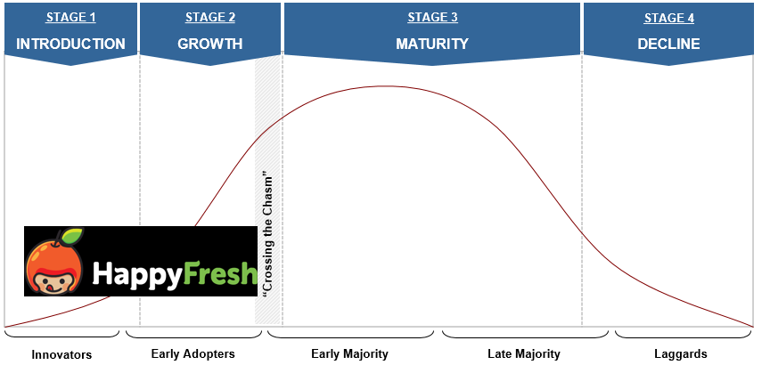

Figure: Product Lifecycle & Consumer Adoption Curve

The Product Lifecycle is typically mapped against the Consumer Adoption Curve to draw out key marketing and competitive insights. The Consumer Adoption Curve is defined by 5 sequential stages: Innovators, Early Adopters, Early Majority, Late Majority, and Laggards.

As our services concept is still consider new to the region, most of our user is consider **Innovators** and **Early Adopters**. The characteristic of these user is as below;

**Innovators** — If you rapidly latch on to products when they’re first introduced, then you’re probably an Innovator. Innovators are eager to try new ideas and products, almost as an obsession. They typically have higher incomes and they are worldlier and more active outside their community. Innovators also rely less on group norms and are more self-confident; they get their information more from scientific sources and experts. This is the group that you always see waiting in line for the new Apple products, regardless of the weather or temperature.

**Early Adopters** — The second group adopts new products early in the product life cycle. Early Adopters rely more on group norms and values, as opposed to Innovators who rely on their own values. They are active inside their community and they want the respect of others. This group is the one to market towards since they are the opinion leaders and encourage their group of family and friends to buy a new product.

Since majority of our users is from above 2 types of consumer, this meant that our services has not been adopted by the majority yet, so there is a lot of room for us to grow. This analysis further support our decision on the growth strategy.

# Section 9: Competitive Analysis & Advantage

We are using Porter’s Five Forces is a framework used because we want to understand exactly how much strong the company in the market and be aware of the competitors

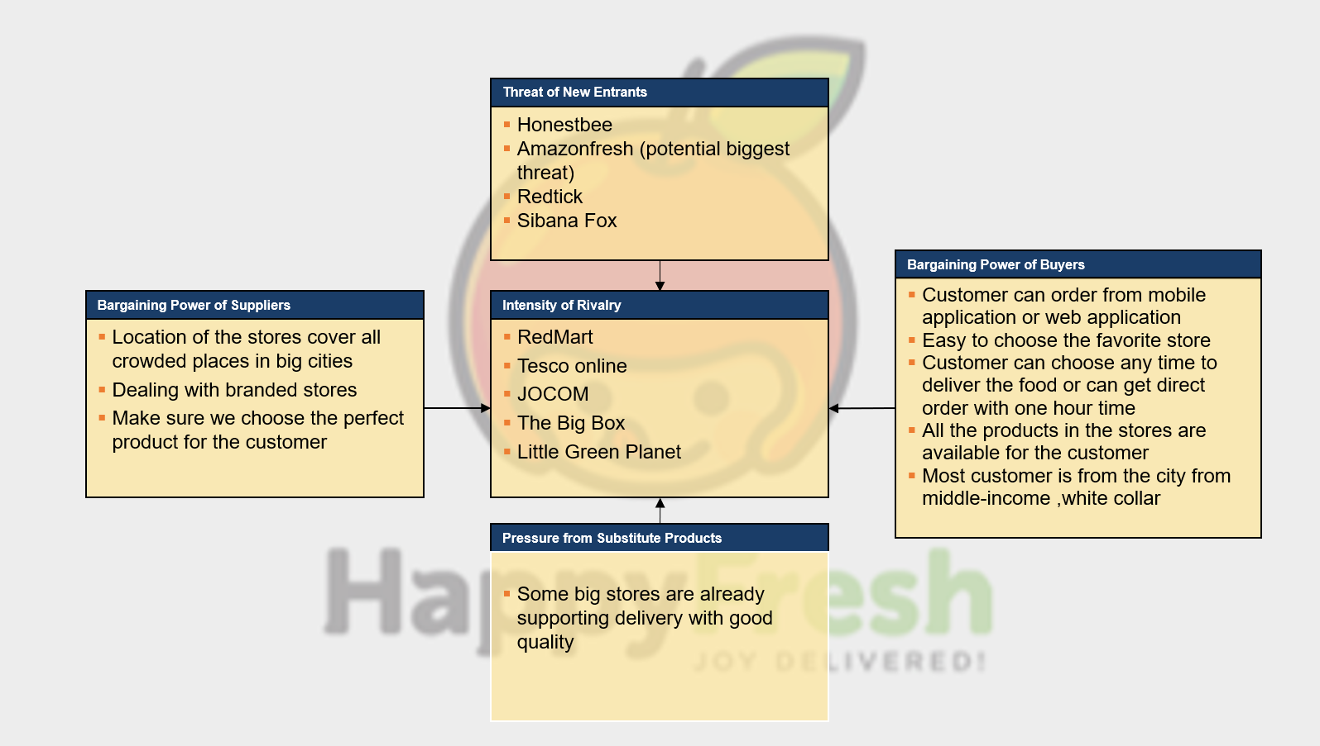

We can see there are a big and older competitor happy fresh should be aware of them and take good plans to compete with them. And the market still open for a new entrains they make also part of threat.

Table: Comparison between HappyFresh and competitors[[6]](#footnote-6)

|  |  |  |  |
| --- | --- | --- | --- |
|  | **HappyFresh** | **HonestBee** | **Redmart** |
| **Similarities and differences** | Couriers use their own bikes | Couriers use their own bikes | Own delivery vehicle fleet |
| Emphasis on asset light operation | Emphasis on asset light operation | Emphasis of quality control |
| Hyperlocalised service with personal shoppers in grocery stores | Hyperlocalised service with personal shoppers in grocery stores | Centralized grocery fulfillment center |
| **Payment Methods** | Credit Card and COD | Credit Card and COD | Paypal and Alipay (after being acquired by Alibaba) |
| **Total Capital** | USD12 million | USD15 million | USD59.89 million |
| **City Coverage** | 3 (Jakarta, Bangkok, Kuala Lumpur) | 2 (Singapore & Hong Kong) | 2 (Singapore & Hong Kong) |
| **Perceived Strength** | * Turn would-be brick-and-mortar competitors into partners * Low initial cost structure (no warehouses, no storage facilities) * Lean methodology allows for fast growth and quick market entries | * The most asset light business out of the 3 (employs part-time shoppers) * Shopper can communicate directly with customer vis SMS * Free delivery for order of USD30 or more | * Run the asset light model for specialty stores only (many more partnering stores) * Price for customer is cheaper because supermarkets are not middlemen * Optimize customer experience * Tight grasp on quality control |
| **Perceived Weakness** | * Less quality controls * Price for customer is more expensive because supermarkets are middlemen * Difficult to scale once business reaches critical mass | * Less quality controls * Price for customer is more expensive because supermarkets are middlemen * Difficult to scale once business reaches critical mass * Customers can only get groceries from selected stores in their proximity | * Creates big-name competitors * Slow to champion new markets * Capital intensive |
| **Shared Challenges** | * Traffic conditions in Southeast Asia markets * Maintaining quality control in second-tier cities * Educating underdeveloped markets * Inspiring trust about online grocery delivery | | |

# Section 10: Marketing Plan

As part of customer’s retention program Happyfresh has introduce the following marketing program to make it their existing user happy and at the same time they can acquire new client based.

1. **Happyfresh Point** - This is to enable HappyFresh to implement a Customer Loyalty program. User of HappyFresh can collect points on every transaction they do. The points can be used later for example to be exchange for a free delivery service, discount or voucher for next purchase. The extension of this HappyFresh can later on integrate with retailer’s partners own loyalty program.
2. **Premium Membership** - A subscription service for user who want to have exclusive services like annual free delivery service or exclusive offers from HappyFresh. It can later be integrated with HappyFresh loyalty program if HappyFresh opted to implement it.
3. **On-Sale Items** - feature or page that displays list of items on sale from each partners store that can be done by weekly or even HappyFresh own promo for its HappyFresh users. This page can later be used for advertisers as well like CPG companies.
4. **Website** - Having another channel where user can use to order beside the mobile app is a good strategy as this enable to cater other user who don’t own an iOS or Android devices or who more familiar in using website rather mobile app.
5. **Recommended Recipe** - A feature that give users suggestion on what recipes they can create off by using the cart contents. The idea is to be able to help user discover new ways to prepare their food. This will subsequently impact the order size by encouraging user to add remaining ingredients when the user like the suggested recipe.

# Section 11: Team

HappyFresh currently employ more than 200 staffs covering 3 locations, namely Jakarta, Kuala Lumpur and Bangkok. Most of the team are located at their HQ in Jakarta, while the rest are at the regional offices. Happyfresh key team members consist of the following:

1. CEO: Guillem Segarra (newly appointed in 2017)
2. CTO and Cofounder: Fajar Budiprasetyo
3. COO and Cofounder: Benjamin Koellmann (also serve as Managing Director for Bangkok Office
4. Vice Chairman and Cofounder: Markus Bihler (previous CEO)
5. CFO: Dr. Konstantin Lange
6. CCO: Kai Kux
7. Executive chairman: Tim Marbach
8. Advisor: Stefan Jung

Since Happyfresh is an online grocery ecommerce, most of their staff are in IT division namely in software development, UI/UX, content writer, graphic design, online marketing, and customer support. Follow by marketing division with support from data analytics team.

Division of labor is a key component of success in any industry, especially for those startups trying to expand rapidly to gain significant market share. Needless to say, HappyFresh has applied regional teams focus on expansion while headquarter takes the rest of jobs methodology into their team by leaving research-and-develop teams in headquarters to deal with and support and technical problems.

This not only helps regional teams focus on marketing and educating customers but also allows these teams to be lean — reducing labor costs. In other words, these teams can concentrate on their specializations and not be distracted by other areas of the company’s business.

# Section 12: Operations Plan

Happyfresh has put a lot of efforts to be in frontline race in the online grocery marketplace. New ideas and innovation are the key point to achieve the objective. Overall, new ideas and innovation put in action would help impacting key business metrics such as user base and revenue. Among new ideas and innovation that had taken place and future implementation are:[[7]](#footnote-7)

1. **Integration with IoT appliance**

The IoT (Internet of Things) is already becoming a tech hype in these past years. In the past CES events, brands like Samsung and LG take a first step in embracing this concept seriously. In the future, we can have electronic appliances that is so smart, it can learn its users’ behavior, operate automatically and users can interact with the devices to make the user lives easier.

HappyFresh doesn’t need to stand on its own to embrace the IoT instead it can choose to collaborate with leading brand like Samsung, LG, Toshiba to integrate HappyFresh app to those respective brand products.

For example:

* A refrigerator that can notify its user through HappyFresh app for items that near its expired date or nearly runs out. The refrigerator then can automatically generate a shopping list that users can decide whether to buy it or not.
* A kitchen set that can decide on what items need to buy on HappyFresh based on user chosen recipe

1. **“Amazon Dash” Like Feature**

Amazon have created a killer product that going to change the game in groceries delivery for the next 2-3 years called Amazon Dash. There are features from Amazon Dash that HappyFresh can inspired from such as:

* + Ability to input your groceries order by voice recognition or bar scanning
  + A feature (or in Amazon Dash case it’s a device) that can be set up to order for specific type of product or brand

1. **Shopping Suggestion (Based on Purchase History or Behaviors)**

A smart feature that able to learn from users past purchase history or behaviour that

can soon understand for example when the user need to shop on items that already near its expired date or know that the items that a user bought will soon run out by estimating a general usage trend of that particular items. The feature will afterward notify user whether he/she need to do its next purchase soon or not.

This smart feature can also be extended to analyses user health rating based on their selection of food items or recipes they favourited.

1. **User Purchase Trends Data** - **Dashboard for Consumer Package Goods (CPG) Brands**

A dynamic dashboard that give aggregated shopping trend data from HappyFresh users. It would capture trends across cross-retailers which in turn will be an interesting data to offer to major CPG companies

1. **Payment Card Tokenization**

A must-have feature for payment nowadays that enable user to save their credit card info so user will not need to always to have input the card numbers etc. every time they do purchase transaction.

1. **Improving User Experiences (Apps and Web)**

* **My Shopping Preference -** User of HappyFresh will likely shop groceries on a regular basis with mostly the same items over and over again. This feature enabling users to save the list of items they buy to be use for next shopping so it will help user save items for not having to input their selection orders again.
* **Multiple Delivery Address -** There are users who shop not only for themselves but for their relatives or parents so this feature enable user to have multiple delivery address that they can choose whenever they are checking out their orders.

Section 13: Financial Projections

As a newly startup company, Happyfresh fund mostly coming from external investor. They received USD12 million in a SERIES A funding in September 2015, and follow by more than USD12 million in SERIES B funding in August 2016.

In the early setup 2014-2015, large portion of the expenses are spent on new hiring for IT team, marketing and operation.

In the recent online news 2017, Happyfresh has allocated huge amount of money (more than USD6 million) into awareness and market growth.

The market for online grocery shopping in Indonesia and other Asian countries could see a double-digit growth in market turnover to be worth S$19 billion ($13 billion) by 2020. It is huge market potential for Happyfresh and other online grocery platform players.

1. https://e27.co/5-reasons-happyfresh-stands-among-grocery-delivery-startups-20160516/ [↑](#footnote-ref-1)
2. https://www.techinasia.com/indonesia-malaysia-grocery-delivery-happyfresh [↑](#footnote-ref-2)
3. Reference : Management Canadian Edition Schermerhorn 🞄 Wright [Chapter 9] [↑](#footnote-ref-3)
4. Reference: Introduction to Business Strategy Development & Execution (UTM lecture notes : Strategic Management Framework(Lecture 1.1) BCG Matrix [↑](#footnote-ref-4)
5. Reference: Introduction to Business Strategy Development & Execution (UTM lecture notes : Strategic Management Framework(Lecture 1.1) Product Lifecycle and Consumer Adoption Curve [↑](#footnote-ref-5)
6. https://www.techinasia.com/southeast-asia-online-grocery-battle-infographic [↑](#footnote-ref-6)
7. https://www.slideshare.net/justalittleslide/potential-future-roadmap-for-happyfresh [↑](#footnote-ref-7)